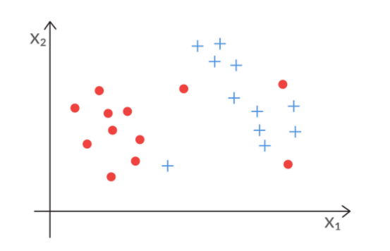
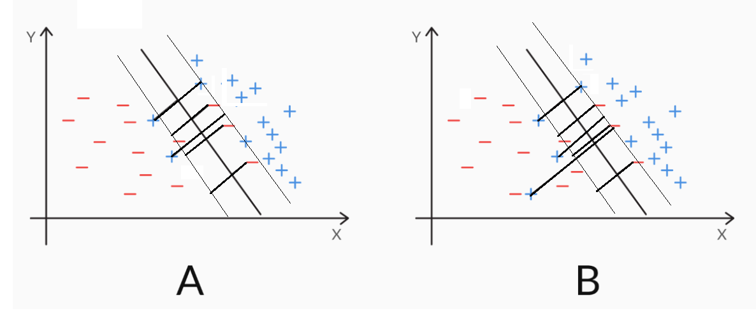
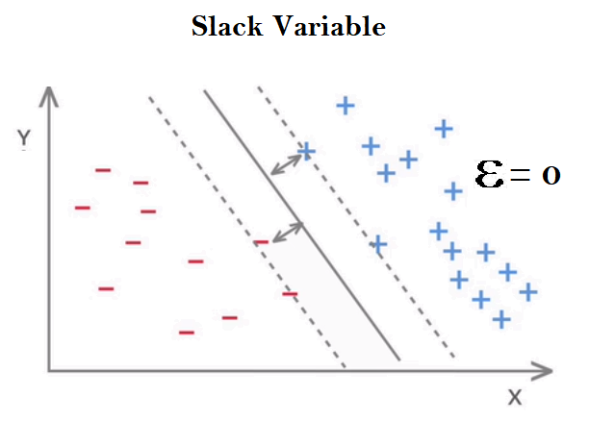
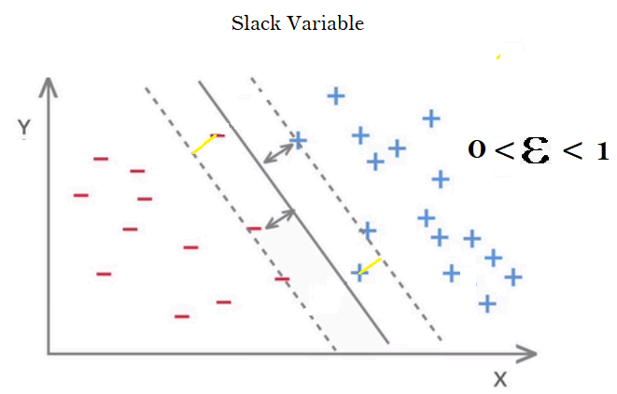
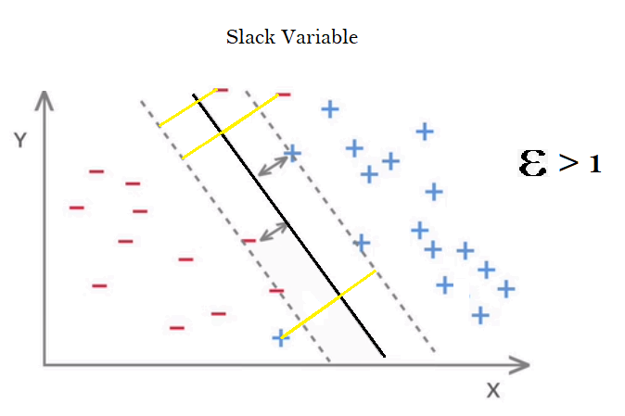
MACHINE LEARNING NOTES:

METHOD: S.V.M (SUPPORT VECTOR MACHINE)

Welcome to the module on 'Support Vector Machines', or SVMs.

You have studied one of the most well-known classification models, i.e. logistic regression. Though these models are widely used in industries such as banking, e-commerce etc. and applications such as default prediction and text classification, they find limited use in more complex classification problems, such as image classification.

SVMs, as you will see, are capable of dealing with quite complex problems, where models such as logistic regression typically fail. SVMs have been extensively used for solving complex classification problems such as image recognition, voice detection etc.

SVMs are mostly used for classification tasks, but they can also be used for regression. The topics covered in this module are limited to classification tasks. In this module, you will apply SVMs to email spam detection and alphabetic letter recognition problems.

In this session
You will understand the following concepts:
- Hyperplane
- Hyperplane in 2D
- Hyperplane in 3D and nD
- Maximal Margin Classifier

Introduction to SVM
Support Vector Machines, or SVMs, are a class of extremely popular classification models. Besides their ability to solve complex machine learning problems, they have numerous other advantages over other classification problems, such as the ability to deal with computationally heavy data sets, classifying nonlinearly separable data, etc. We will discuss some of these problems in detail in the upcoming lectures.

It is important to remember that SVMs belong to the class of linear machine learning models (logistic regression is also a linear model). This concept will be very important in the upcoming lectures.

A linear model uses a linear function (i.e. of the form y = ax +b) to model the relationship between the input x and output y. For example, in logistic regression, the log(odds) of an outcome (say, defaulting on a credit card) is linearly related to the attributes x1, x2, etc.

log(odds of defaultING OF A GIVEN CREDIT CARD)=β0+β1X1+β2X2+...βnXn

Similarly, SVMs are also linear models. In the upcoming lectures, you will learn to use SVMs for classification problems.

SVMs need attributes in the numeric form. In our (somewhat simplified) example of email classification, the features are the ‘frequency of words’ in an email. Word frequency is a very common type of feature in text classification, and reasonably so. For example, words such as ‘Hurry’, ‘FREE’ and ‘Discount’ are likely to be more frequent in spam emails than ‘meeting’, ‘PPT’, ‘weekly report’, and others that are characteristic of office emails.
To summarise, SVMs are linear models that require numeric attributes. In case the attributes are non-numeric, you need to convert them to a numeric form in the data preparation stage.

Before you move on to support vector machines, you need to understand the concept of hyperplanes. Essentially, it is a boundary which 'separates' the data set into its classes (in this case, separates spam emails from the ham ones). It could be lines, 2D planes, or even n-dimensional planes that are beyond our imagination.

You can find the data dictionary of the email spam dataset from the UCI repository link here and download the processed data set from the link below

SEE FILE IN COMPUTER NAMED
“ Spam.csv”

A line that is used to classify one class from another is also called a hyperplane. In fact, it is the model you're trying to build as shown in the figure-1 below-
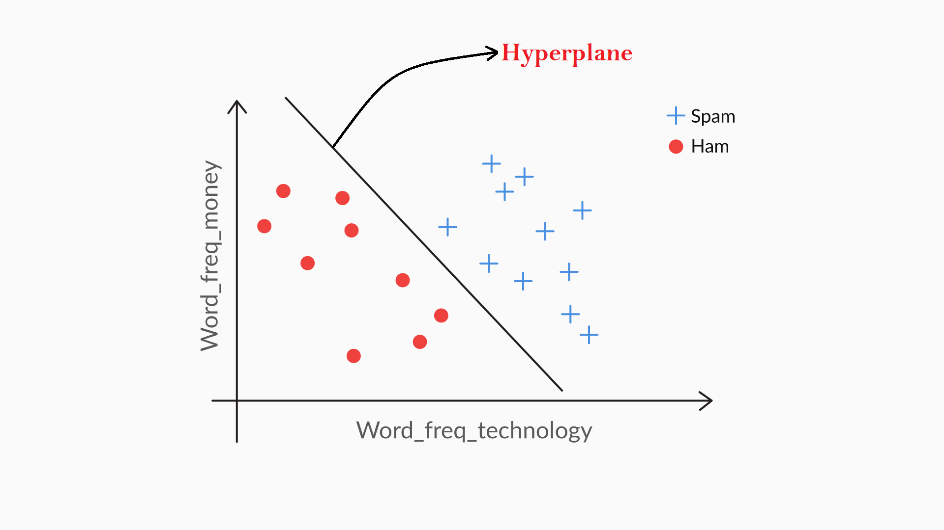
Figure-1: 2D- Hyperplane

The standard equation of a line is given by ax+by+c = 0. You could generalise it as W0+W1x1+W2x2=0, where x1 and x2 are the features — such as 'word_freq_technology' and 'word_freq_money' — and W1 and W2 are the coefficients. For any line with W coefficients, substituting the value of features x1 and x2 in the equation of the line determined by its W coefficients, will return a value.

A positive value (blue points in the plot above) would mean that the set of values of the features is in one class; however, a negative value (red points in the plot above) would imply it belongs to the other class. A value of zero would imply that the point lies on the line (hyperplane) because any point on the line will satisfy the equation: W0+W1x1+W2x2=0.
This is what a 2-dimensional hyperplane looks like. Now, what do you think a hyperplane will look like in 3 dimensions? We will discuss this in the next lecture

As you learnt in the last lecture, a 2D hyperplane can be represented by a line, and the equation of this hyperplane will be expressed as ax+by+c = 0. But if you have 3 attributes, what will the hyperplane look like, and what will the expression of such a hyperplane be? Let’s discuss this.

In general, you can conclude that the hyperplane in 2D can be represented by a line, whereas a hyperplane in 3D can be represented by a plane.

Now, let’s see how you can extend the 2D expression for 3D and for a d-dimensional space.

In 3 dimensions (refer to figure 1 below), the hyperplane (light orange) will be a plane with an expression of ax+by+cz+d = 0. The plane divides the data set into two halves. Data points above the plane represent one class (red), while data points below the plane represent the other class (blue).

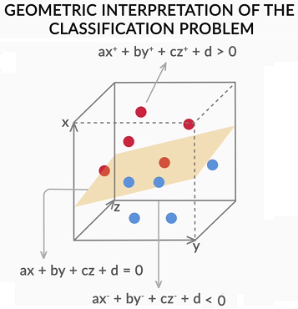
Figure-1:3D Hyperplane
In general, if you derive the d-dimensional hyperplane from d attributes, you can write the expression as follows:

∑di=1(Wi.Xi)+W0=0
The model denoted by the expression given above is called a linear discriminator. Let's learn more about linear discriminator expression from our SME. The correct equation is as followed:

If li=1 then,
∑di=1(WiXi)+W0>0

If li=−1 then,
∑di=1(WiXi)+W0<0

Similar to the 2D and 3D expressions, an n-dimensional hyperplane also follows the general rule: all points above the plane will yield a value greater than 0, and those below it will yield lesser than 0 when plugged into the expression of the hyperplane.

Let’s focus our discussion on the 2-dimensional case again. Consider the hyperplanes (lines) drawn below. You can have multiple such lines correctly performing the classification task. But don't you think it would be a better idea to see which one is best suited?
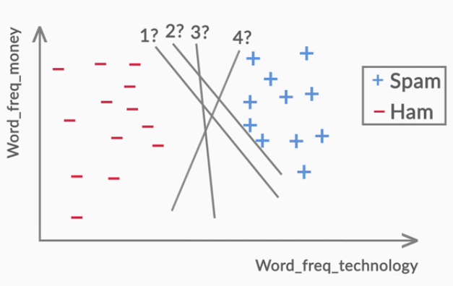
Figure-2: Best Hyperplane
In the next lecture, you will learn how to choose the best-fit hyperplane.

Maximal Margin Classifier
In the previous lecture, you learnt how a line (hyperplane) can be generated so that it perfectly separates two classes: spam and ham. However, there could be multiple lines (or hyperplanes in general) possible, which perfectly divide the two classes.(see previous figure). Let’s learn how to get the optimum hyperplane.

The best line is the one that maintains the largest possible equal distance from the nearest points of both the classes. It is also referred to as a maximal margin classifier. You can think of the margin as a 'band' that the hyperplane has on both its sides.

There can be several lines (hyperplanes) possible in the same data set, as shown in the figure below, with different values of margins. Among these, the line with the maximum margin would be considered the best fit line for the given data.

Suppose you’ve three different hyperplanes with three different margin values. Which hyperplane is the best for this data?

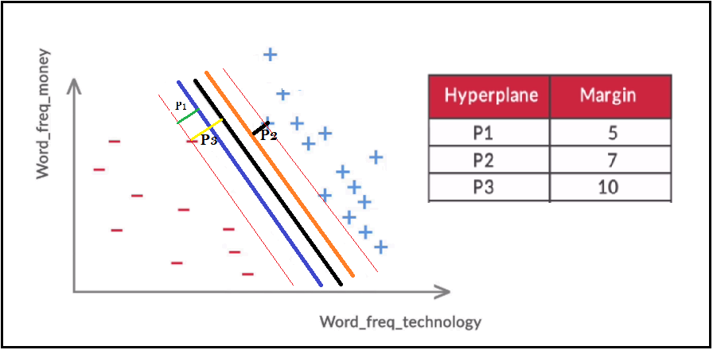
Figure-1: Best Maximal Margin Hyperplane
It's obvious, from the given margin values, that the third hyperplane is the best of the lot. Why? Because it maintains the maximum margin value.

But finding the maximal margin hyperplane needs a mathematical formulation. Let's now understand the formulation for an optimal maximal margin classifier.

Note: In the coming lectures, you will need to recall the concept of dot product of two vectors. Say there are two vectors A = [2, 3, 5] and B = [1, 0, 4], then the dot product of A and B is the element-wise multiplication of A and B, i.e. transpose(A). B = A'B = 2.1 + 3.0 + 5.4 = 22. Note that the dot product of two vectors returns a scalar number, in this case, 22.

Quick Refresher on SVM Notations
Before we move further in this session, let's get familiar with a few notations that are used in the SVM formulation.

Distance Formula for a Hyperplane
In the next lecture, you will learn about the distance formula from a hyperplane. You can read more about the distance formula here
https://mathworld.wolfram.com/Point-PlaneDistance.html

Now that you are comfortable with the notations, let's move forward.

In the following video, prof. Raghavan will explain how do you find the maximum margin classifier mathematically.
The mathematical formulation requires two major constraints that need to be taken into account while maximising the margin. They are
- The standardisation of coefficients such that the summation of the square of the coefficients of all the attributes is equal to 1. For example, if you have 20 attributes, then the summation of square of the coefficients should be ∑20i=1(W2i)=1
- Along with the first constraint, the maximal margin hyperplane should also follow the constraint given below:
(liX(Wi.Yi))⩾M
where,
li = label (1, -1)
Wi = coefficient of attributes
Yi = data points of all the attributes in each row

Let's understand these contraints through an example, since you already know how to write an equation for a hyperplane in 2D. Now say that the hyperplane is represented as W0+W1X1+W2X2=0. So what you need to do is apply both the constraints in this equation such that you get a maximal margin hyperplane equation that maintains an equal distance from both the labels, as shown in figure 2 below.

The first constraint should be valid if W20+W21+W22=1.

For the second constraint, the hyperplane should be a safe distance of more than or equal to the margin 'M' from both the labels. If you look at figure 2(A), all the red dots are below the hyperplane that is labelled (-L). Here, the multiplication of (-L), with the dot product of Y(p,q) and the equation W0+W1X1+W2X2, will give you a positive value that is greater than or equal to 'M'.

Similarly, if you look at figure 2(B), all the blue dots are above the hyperplane that is labelled (+L). Here, the multiplication of (+L), with the dot product of Y(p,q) and the equation W0+W1X1+W2X2, will also give you a positive value that is greater than or equal to 'M'.
'.

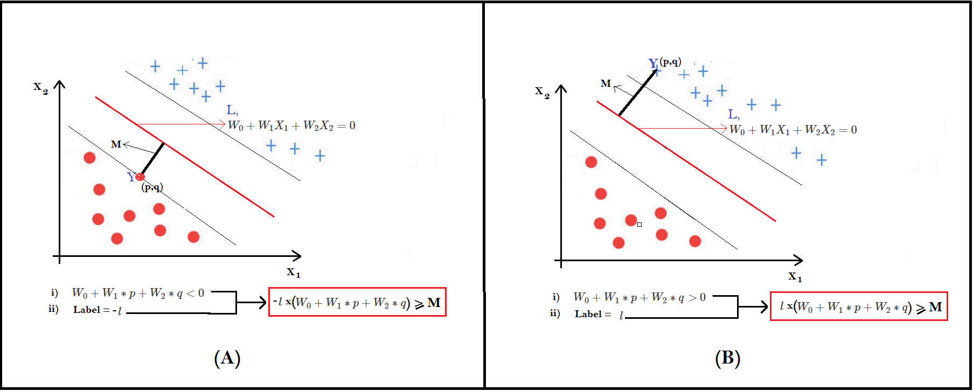

Figure-2:Maximal Margin Classifier

This is how the constraints help in formulating the maximal margin hyperplane.

The maximal margin line (hyperplane), although it separates the two classes perfectly, is very sensitive to the training data. This means that the Maximal Margin Classifier will perform perfectly on the training data set. But on the unseen data, it may perform poorly. Also, there are cases where the classes cannot be perfectly separated. For example, if you look at figure 3 below, do you think the maximal margin can classify the data points perfectly?
Figure-3: Partially Intermingled data
It seems that the maximal margin line (hyperplane) is not even possible in this case. In this case, if you want to create a linear hyperplane, you will inevitably need to misclassify a few data points. In other words, some points will need to fall on the wrong side of the hyperplane.

You will learn how to build such a classifier in the next session- the Soft Margin Classifier.

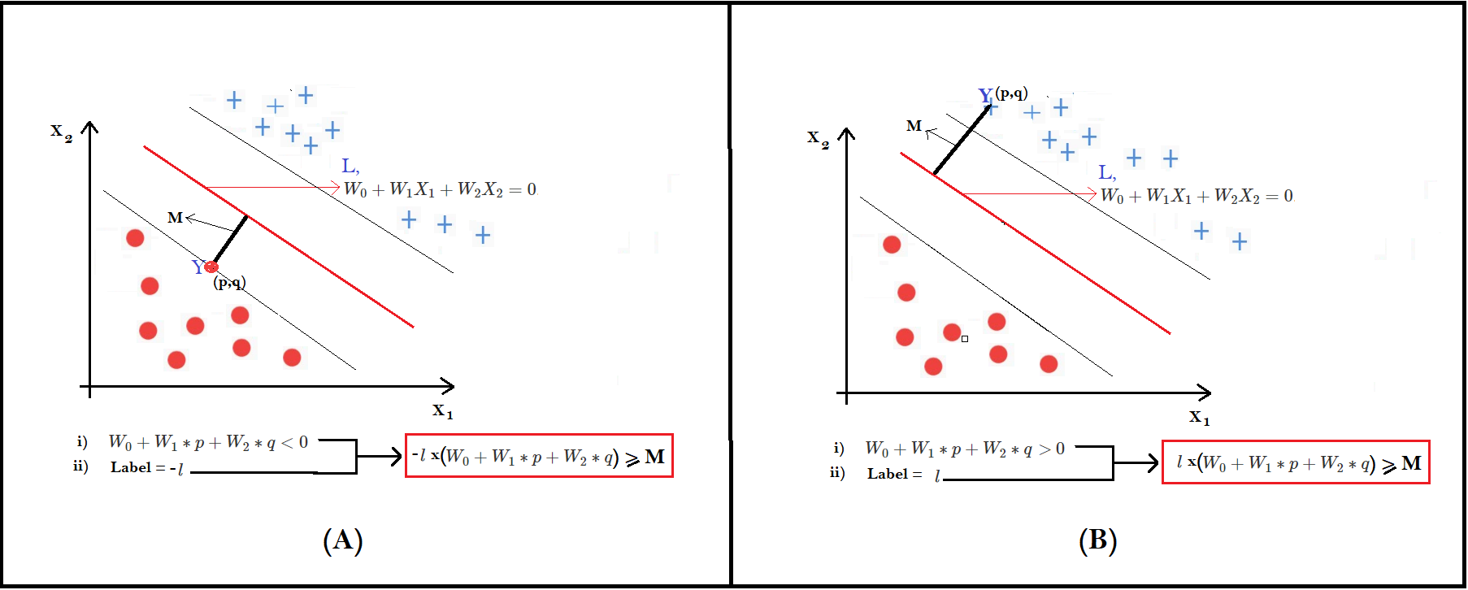
Figure-2:Maximal Margin Classifier
This is how the constraints help in formulating the maximal margin hyperplane.

Introduction
Welcome to the session 'Soft Margin Classifier'.

the maximal margin classifier has some serious limitations. For example, it is possible only on data sets which are perfectly linearly separable, which occur rarely in real life.
it cannot classify data points if they are partially intermingled, as shown below:

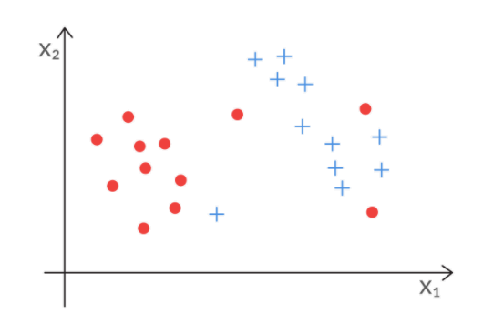
To summarise, support vectors are the points that lie close to the hyperplane. In fact, they are the only points that are used in constructing the hyperplane.

The hyperplane that allows certain points to be deliberately misclassified is also called the Support Vector Classifier.

The support vector classifier works well when the data is partially intermingled (i.e. most of the data can be classified correctly with some misclassifications).

Similar to the Maximal Margin Classifier, the Support Vector Classifier also maximises the margin; but it will also allow some points to be misclassified, as shown in figure 2(A & B) below.

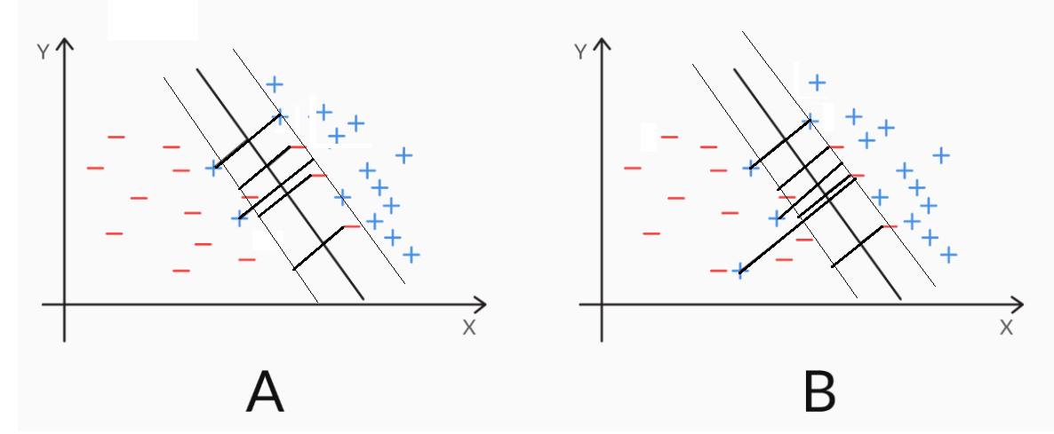
Figure-2: Soft Margin Hyperplane

Now, the question is, how do you find the best Support Vector Classifier? This is what you will learn in the next lecture.

We looked at the concept of the slack variable(ϵ). A slack variable is used to control misclassifications. It tells you where an observation is located relative to the margin and hyperplane.

For points which are at a distance of more than M, i.e. at a safe distance from the hyperplane, the value of the slack variable is 0.
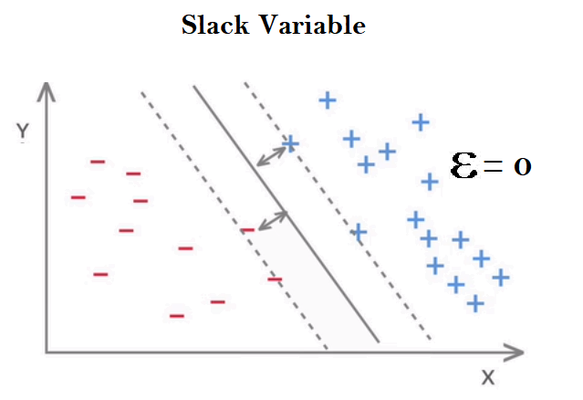
Figure-1(A) - Slack variables (ε=0)
On the other hand, if a data point is correctly classified but falls inside the margin (or violates the margin), then the value of its slack ϵ is between 0 and 1. In the plot given below, the blue and the red points, which fall inside the margin, are examples of such points.
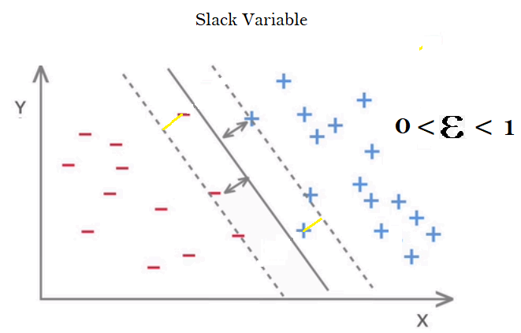
Figure-1(B): Slack Variables (0 < ε < 1)

Finally, if a data point is incorrectly classified (i.e. it violates the hyperplane), the value of epsilon (ϵ) > 1. The incorrectly classified blue and red points are such examples.
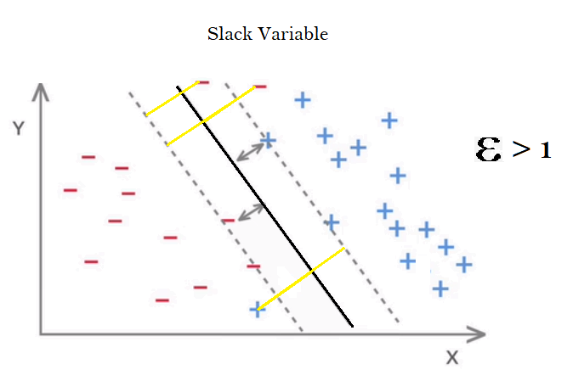
Figure-1(C): Slack variables ( ε > 1 )

So you can see that
- Each data point has a slack value associated to it, according to where the point is located.
- The value of slack lies between 0 and +infinity.
- Lower values of slack are better than higher values (slack = 0 implies a correct classification, but slack > 1 implies an incorrect classification, whereas slack within 0 and 1 classifies correctly but violates the margin).

Once you understand the notion of the slack variable, you can easily compare any two Support Vector Classifiers. You can measure the summation of all the epsilons(ϵ) of both the hyperplanes and choose the best one that gives you the least sum of epsilons(ϵ). The summation of all the epsilons of each data point is denoted by cost or 'C', i.e.
∑ϵi≤C.

When C is large, the slack variables can be large, i.e. you allow a larger number of data points to be misclassified or to violate the margin. So you get a hyperplane where the margin is wide and misclassifications are allowed. In this case, the model is flexible, more generalisable, and less likely to overfit. In other words, it has a high bias.

On the other hand, when C is small, you force the individual slack variables to be small, i.e. you do not allow many data points to fall on the wrong side of the margin or the hyperplane. So the margin is narrow and there are few misclassifications. In this case, the model is less flexible, less generalisable, and more likely to overfit. In other words, it has a high variance.

Q:: Cost of Misclassifications
Which of the following steps should be taken when the SVM is overfitting?
Add more training data
Increase the value of C
All of the above: CORRECT ANSWER
Feedback:
Yes, adding more training points and increasing value of C will reduce model overfitting problem. Because if you train the model on a large number of data, it will try to learn from the data rather fitting to the each data points. and if you increase the value of C, ultimately you are allowing your model to misclassify some data points. And, hence, the model will not be overfitted in these two cases.

As you have already learnt, the mathematical formulation for the Maximal Margin Classifier can be expressed as

liX(W.Yi)>=M

where
- li represents the label of the ith observation (such as spam(+1) and ham(-1));
- W represents the vector of the coefficients (or weights) of each attribute (for example, if you have 3 attributes, W = [w0, w1, w2, w3]).
- Yi represents the vector of the attribute values for the ith row, e.g. Y = [y1, y2, y3] for 3 attributes.
Thus, the dot product W.Yi is simply the value of the expression obtained by putting the ith data point in the hyperplane equation, i.e. W.Yi=w0+w1y1+w2y2+w3y3.

Thus, W.Yi is lesser than, equal to or greater than 0, depending on the location of the ith data point with respect to the hyperplane. Also, note that the value of W.Yi gives you the distance of the ith data point from the hyperplane.

- M represents the margin, i.e. the distance of the closest data point from the hyperplane.

If you impose the condition (liX(W.Yi)>=M) on the model, then you are implying that you want each point to be at least a distance M away from the hyperplane. But unfortunately, few real datasets will not be so easily, perfectly separable. Thus, to relax the constraint, you include a ‘slack variable’ εi for each data point i.

Thus, you modify the formulation to (liX(W.Yi)>=M(1−εi),

Where the slack variable (εi) takes a value between 0 to infinity.

Depending on the value of εi, the ith data point can now take any position - it can fall on the correct side of the margin (and a safe distance away), or inside the margin (but still correctly classified), or even stray on the wrong side of the hyperplane itself.

Q: Notion of Slack Variables
As you learnt, the summation of all the epsilon is equal to cost “C” So, what happens when C is large, say 100, and what happens when C is small, say 5?
Compare the two cases on the basis of:
- In which case would a higher number of points be misclassified?
- In which case is the model more likely to overfit?
Write your answer in the box below.

ANSWER :
If C is large, then the slack variables ​εi​ can take higher values. And you know that when slack(​εi​) > 1, the point is misclassified,and when between 0 and 1, it falls inside the margin, and when slack(​εi​) = 0, it is correctly classified. Thus, for higher C, more points will be allowed to get misclassified or fall inside the margin (compared to a lower C). On the other hand, a lower C implies that each slack(​εi​) will have to take a lower value, and thus not be allowed to stray on the other side of the margin or the hyperplane. This is a more strict condition.In other words, a lower C does not give the model freedom to misclassify even a few points, and thus the model tries to overfit the data.

Q: Support Vector Classifier
The two figures (A and B) below represent two values of C used to fit a hyperplane — one is small and the other is large. According to you, which hyperplane will be the best fit for the given data?

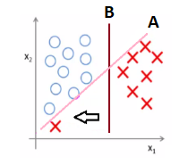

ANS: B

Q: Cost
Overfitting refers to a case where a model tries to fit the available training data (often) without representing the underlying relationship between the input and output variables. Which of the two hyperplanes can be said to have overfit the training data?

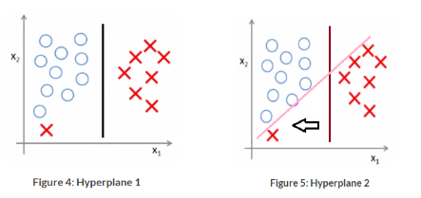

Hyperplane 1
Hyperplane 2: ANSWER
Feedback:
Hyperplane 2 is overfitting because it has classified all the training points correctly; this may lead to more chances of model bias

SVM Python Lab - I
Now that you are familiar with the concepts of SVM, let's dive into a quick implementation of it in Python. We'll use an email data set to classify emails as spam or ham
The dataset is taken from the UCI machine learning repository. Most features in the dataset represent count of certain words, denoted by names such as word_frequency_meeting, word_frequency_free etc. Some other features represent features typical of spam emails, such as the maximum length of 'all uppercase words' ('FREE OFFER'), the frequency of non-alphanumeric characters ('!!!!') etc.

You are required to follow the lecture by downloading the python file and the dataset given below.
(see computer)

Data Preprocessing
Step 1: Rescaling the features (standardising or normalising) so they are all on a comparable scale
Rescaling is an important step since some features may range from a extremely small range of numbers (say fractions) and others may be orders of magnitude higher (say 10k-100k). This may cause some features (in SVMs, they are 'dimensions') whose values are higher to dominate over others.
Important Note: The hyperparameter C has a different meaning in the python SVC() implementation

Please note that the parameter C that you used in the SVM formulation (in the theory lectures) and the C in the SVC() function are the inverse of each other.

Previously, we discussed how C is the sum of all the slack variables, and thus, a large value of C implies that you are willing to accommodate a higher number of misclassifications (and thus, the model is more generalisable since it does not have to worry about classifying all the points correctly). According to this definition, a large C ensures that the model will not overfit.

In other words, a high value of the parameter C, as discussed earlier, regularizes the SVM model.

On the other hand, in the SVC() implementation of python that you will use, the hyperparameter C is analogous to the penalty imposed for misclassification, i.e. a higher C will force the model to classify most (training) data points correctly (and thus, overfit). In sklearn, high value of C implies a high cost of making errors or misclassifications.

